Title: | LIN network Slave 4  SW Component MPC5606B

Review History
Issue status  (Index) | Maturity/Date  (draft/invalid/valid)  (dd-mmm-yyyy) | Author  Department | Check/Release  Department | Description
1.0 | Draft  04-0ct-09 | Miguel Garcia | Miguel Garcia | Creation of the document
1.1 | Draft  29-Nov-15 | Jorge Luis Gomez and Jose Luis Matinez | Luis Alvares | added chapters 1, 2, 3, 4,5

Table of Contents
1 Purpose 3
2 Definitions and abbreviations 3
3 Realization constraints and targets 3
4 SW Conceptual design 4
5 SW Component internal breakdown 6
5.1 Functional Decomposition 6
5.2 Function <void> <main> (void) 7
5.3 Function <void> <Init_System> (void) 8
5.4 Function <void> <init_LINflex_Slv> (void) 9
5.5 Function <void> <LINflex_StateMachine> (void) 10
5.6 Function <void> <Slave_Actions> (void) 11
5.7 Function <void> <LED_StateMachine> (void) 12

Purpose
This document provides the information necessary for design a communication of LIN (Master-slaves). Except that is for implementing a slave and the master is a PC which is already configured for operation with the slaves. The functionality of this slave is to light a LED or toggling, beside send status to the master. This functionality may vary.

Definitions and abbreviations
Definitions
Scheduler | is the method by which work specified by some means is assigned to resources that complete the work.
Frame | It is the plot of a message sent by a peripheral communication or protocol
Kernel | Is a program that manages input/output requests from software, and translates them into data processing instructions for the central processing unit.
Embedded | It is a system designed to perform one or a few dedicated functions, often in a real time system.

Abbreviations
LIN Local Interconnect Network
MCU Microcontroller
PIT Periodic Interrupt Timer
ID Identifier
GPIOs General-Purpose Input and Output
References
N° | Document name | Reference
1 | MPC5607B Microcontroller Reference Manual
2 | Traceability Matrix LIN.xls
3 | LIN_Network_Database.xls
4 | LIN Specification Package Revision 2.2

Realization constraints and targets

Implement a communication using the LIN communication protocol, this design is for implementing an slave, the functionality on or toggling a LED when the master of the communication will also send an order status.

SW Conceptual design

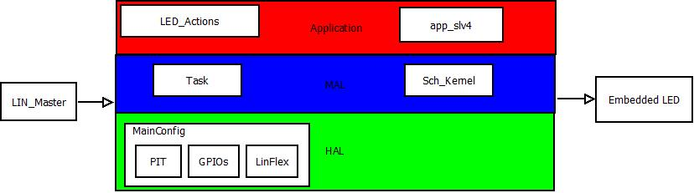
Fig. 4.1 Architecture Design of LIN network Slave 4

Figure 4.1 shows resources that are used in the different layers. In the HAL GPIOs are used as inputs and output of led, also PIT provides periodic interruptions known as TICs, these are determined by the user to perform the tasks in the time it was planned in the scheduler, Mal provided drivers for control of hardware with application so that here initialized peripherals, Kernel and tasks in this case.
Lastly Application shall contain LED_Actions which in turn it contains the LED status and shipping status.

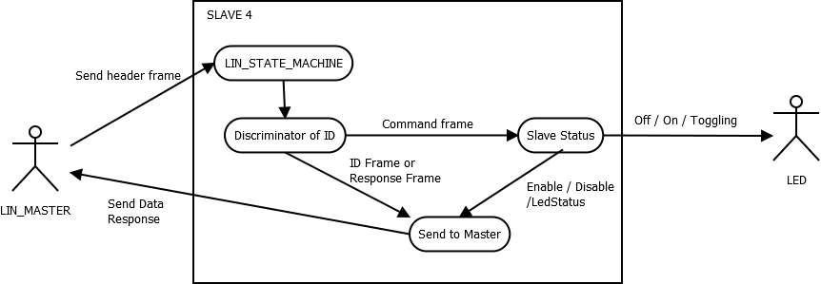
Fig. 4.2 Case Diagram

In Figure 4.2 user interaction and system response shown can also observe a simple visualization of the communication to be held.

Figure 4.3 shows deployment proposed system, their software and hardware components and their relationship.
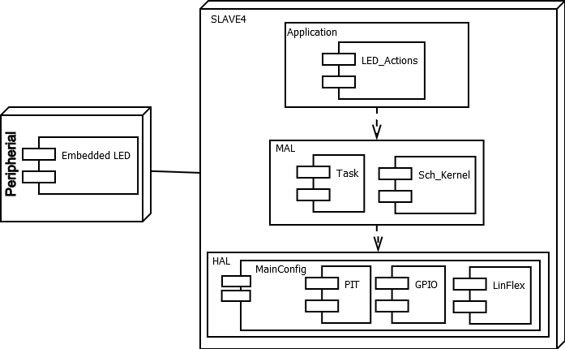
Fig. 4.3 Deployment and Component Diagram

The sequence diagram shows the behavior after making a validation of a frame.

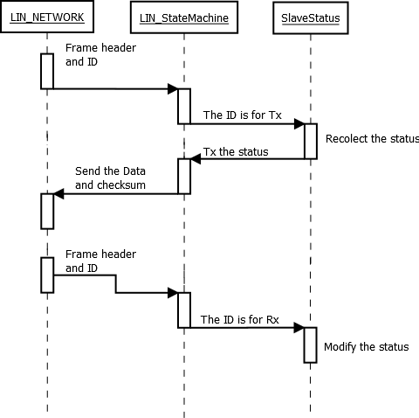
Fig. 4.4 Sequence Diagram

SW Component internal breakdown
LIN Slave 4 will be composed for several modules:
- One Initialization module that initializes the GPIO and the PIT and It takes of control the interruptions
- A LINflex initialization module that initializes the LIN slave
- A LIN Slave4 module that traduces
- A Slave action module that contains the application (Turn on, off and toggling a LED)
- A Kernel module that the executions of the tasks
- A Task module that contains the tasks

Due to the ability of hardware using many of the methods of LIN are not needed, because is done it by itself. In that way the CPU load is minimized. Req. 2.0 to 4.15

Functional Decomposition
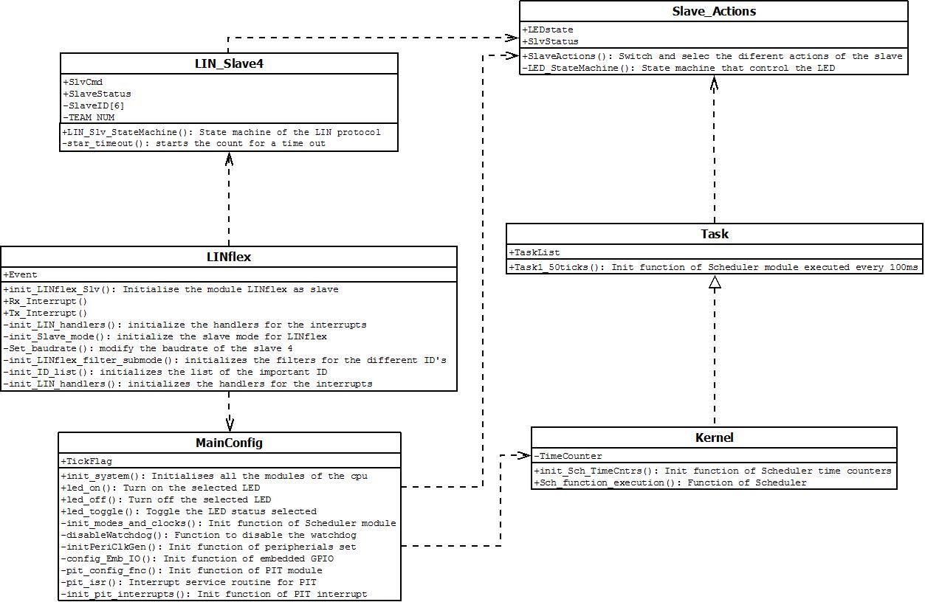
Function Description and Dynamic Behavior

Function <void> <main> (void)

Description | Main function of the program
Parameter 1  <input > | Void
Return Value | Void
Precondition | The correct initialization of the startup code.
Post condition | The cpu can be configured and the program can start.
Error Conditions | -

Dynamic Behavior
Flow Chart

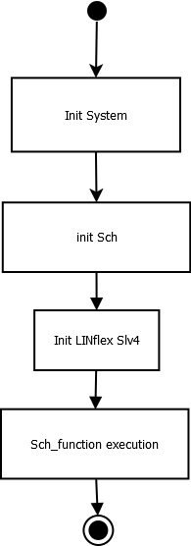

Function <void> <Init_System> (void)

Description | Initialize all the modules of the cpu
Parameter 1  <input > | Void
Return Value | Void
Precondition | This function must be called after correct startup.
Post condition | All the cpu and the peripherials are initialized.
Error Conditions | -

Dynamic Behavior
Flow Chart
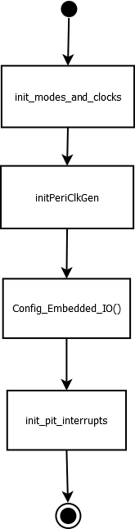

Function <void> <init_LINflex_Slv> (void) Req. 4.0 to 4.15, 7.13

Description | Initializes the LINflex and its functionalities
Parameter 1  <input > | Void
Return Value | Void
Precondition | The correct initialization of the startup code.
Post condition | The LINflex module is enable to work with the ID’s for slave 4
Error Conditions | -

Dynamic Behavior
State Chart
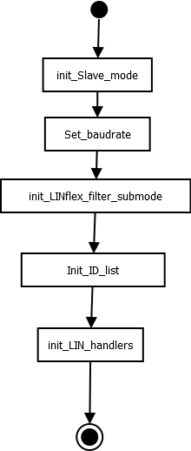

Function <void> <LIN_Slv_StateMachine> (void) Req. 4.3, 4.7, 4.11, 4.15

Description | State machine for the actualization of the parameters of the slave 4
Parameter 1  <input > | E_INTERRUPT_EVNT
Return Value | void
Precondition | An interrupt must occur
Post condition | The system is going to go down and wait 5 seconds and before that the system can read new commands.
Error Conditions | -

Dynamic Behavior
State Chart
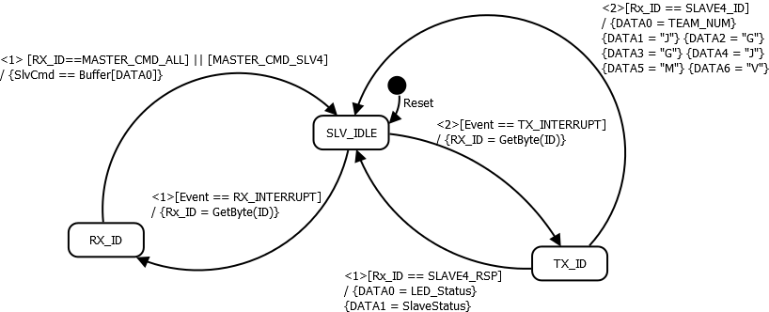

Function <void> <Slave_Actions> (void) Req. 7.3, 7.7 to 7.9

Description | Change the Status of the slave and the LED called every 50ms
Parameter 1  <input > | void
Return Value | void
Precondition | The periodic task is called
Post condition | The slave change its status
Error Conditions | -

Dynamic Behavior
State Chart
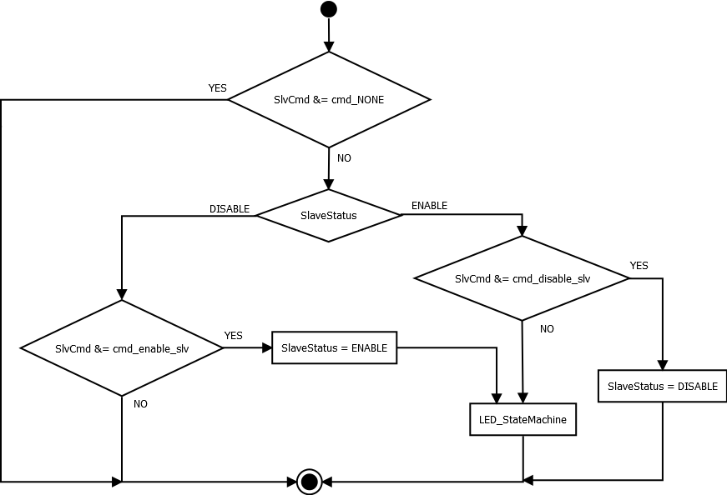

Function <void> <LED_StateMachine> (void) Req. 7.4 to 7.6, 7.10 to 7.12

Description | State machine of the behavior of the LED, executed every 50ms
Parameter 1  <input > | void
Return Value | void
Precondition | The periodic task is called
Post condition | Switch the status of the LED
Error Conditions | -

Dynamic Behavior
State Chart

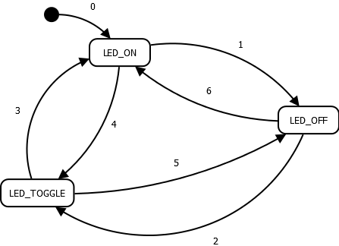
0 | Reset
1 | <1> [SlvCmd &= cmd_LED_off] / {led_off() } {LED_Status=OFF}
2 | <1> [SlvCmd &= cmd_LED_toggling] / { led_toggle() }{LED_Status=TOGGLING}
3 | <1> [SlvCmd &= cmd_LED_on] / { led_on() }{LED_Status=ON}
4 | <2> [SlvCmd &= cmd_LED_toggling] / { led_toggle() }{LED_Status=TOGGLING}
5 | <2> [SlvCmd &= cmd_LED_off] / { led_off() }{LED_Status=OFF}
6 | <2> [SlvCmd &= cmd_LED_on] / { led_on() }{LED_Status=ON}

